Sample Announcement (Before Mass)

Welcome to Sensory-Friendly Mass here at St. Joseph Catholic Church. Our parish is collaborating with Archdiocese of Philadelphia to establish regular Sensory-Friendly Masses across the region.
These liturgies are intended to welcome all people to the Supper of the Lord. Some changes that you might notice during this Mass are lower lights, softer music, visual aids, ^ and a more literal Homily, but the biggest difference is that this is a stigma-free environment. That means, that every person in this church is welcome to enter into the Mass as they are. If you need to get up and move around, that is fine. Vocalizations are welcome, but if you need to take a break, we have a Sensory Room available in the Catherine of Sienna Room just down the hall. There are signs available to direct you to this space.
We also have (alternative seating, fidgets, noise cancelling headphones, adaptive missals, Worship Aids, etc) available out in the gathering space, and you can find more details in your Worship Aid. If you need any other accommodations or assistance, please reach out to one of our ushers.
Finally, if you would prefer to receive a low-gluten host, Deacon Chris will be offering them in front of the Ambo during Communion.
Thank you and we are so glad to have you at this liturgy.

__________________________________________________________________________________
*Please note only to include the accommodations that your parish is prepared to offer.
^ reading from the Children’s Lectionary – this could be an option a parish makes on occasion. This is not encouraged by the Office of Divine Worship on a regular basis for Sunday Liturgies.

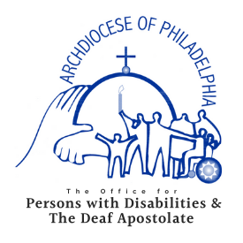

www.OPDarchphilly.org

